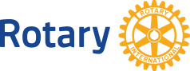 C:\Documents and Settings\Dr\Local Settings\Temp\Rar$DI01.203\T1516-EN.eps 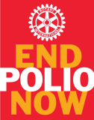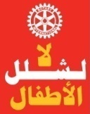

Dear

It is with great pleasure that we extend a special invitation to you to join us in welcoming the **RI President Elect 2016-2017, John Germ and his wife Judith**who will honor us with their visit to our Rotary District 2452 [9 countries] between the **4th – 6th of September, 2015**to celebrate **Rotary's 30th Anniversary of Polio Plus** in Beirut, Lebanon.

Besides the ***First District 2452 Polio Seminar***which will be held on Sunday, the 6th of September, you will have the chance to meet with District 2452 **Youth and the Rotary family at large**during an amazing lunch event on Saturday, the 5th of September. Our celebrations will be concluded with a***Gala Fundraising Dinner***on Sunday, the 6th of September at “Casino du Liban”.

At the Polio District 2452 Seminar, participants will listen to experienced and prominent speakers from Global Polio Eradication Initiative Partners where discussions on different relevant subjects on polio will take place including the opportunity to ask questions. During the seminar a “Declaration on Polio” will be signed by District 2452 and other partners. The Polio District seminar will be trilingual – Arabic, English and French with instant translation and will be held at “Hilton Habtoor Grand hotel” in Beirut.

Besides the Rotary fellowship, there will be lots of opportunities for you to interact with Rotarians and senior leaders from different countries during the different activities. A copy of the tentative program and the registration form is included for your kind attention.

**Please note that all proceedings from this historical program will go directly to the End Polio Now Fund.**

We, the Rotarians of District 2452 are all eager to see you in magical Beirut in a couple of months.

**Yours in Rotary**

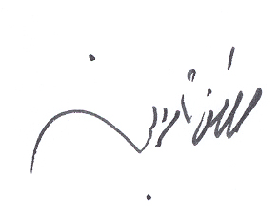 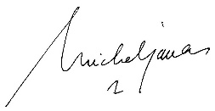

**Mustafa Nasereddin Michel P. Jazzar** District 2452 Governor | 2015-16 | D.2452 Polio SC Chair | 2015-16 | Honorary chairman Organizing Team Chairman Organizing Team