STRATEGIC PLAN

https://www.rotary.org/myrotary/en/learning-reference/about-rotary/strategic-plan
Rotary’s strategic plan provides the framework for our future, ensuring that we continue to be known as a respected, dynamic organization that advances communities worldwide.
The strategic plan evolves with the aspirations of Rotarians. It is shaped by regular input from members through surveys, focus groups, committees, and meetings, so it can continue to help us achieve our goals.
Read the latest strategic plan progress report.

OUR STRATEGIC PRIORITIES AND GOALS
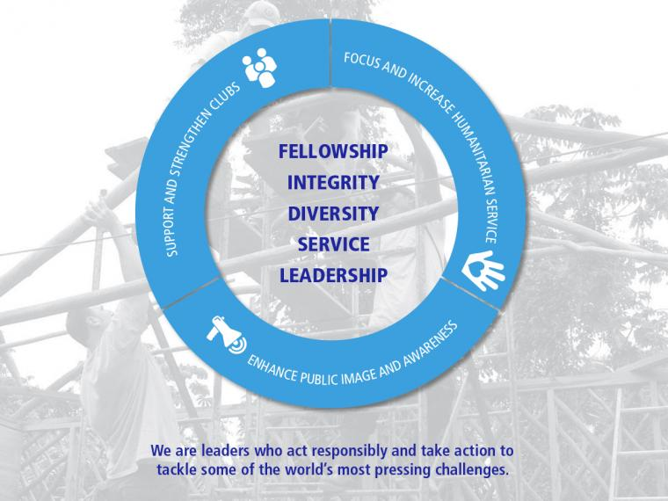
Rotary’s strategic plan identifies three strategic priorities supported by 16 goals. They represent what Rotarians have asked to be done to ensure a strong and vibrant Rotary going into the future.

SUPPORT AND STRENGTHEN CLUBS
- Foster club innovation and flexibility
- Encourage clubs to participate in a variety of service activities
- Promote membership diversity
- Improve member recruitment and retention
- Develop leaders
- Start new, dynamic clubs
- Encourage strategic planning at club and district levels

FOCUS AND INCREASE HUMANITARIAN SERVICE
- Eradicate polio
- Increase sustainable service focused on programs and activities that support youth and young leaders and Rotary's six areas of focus
- Increase collaboration with other organizations
- Create significant projects both locally and internationally

ENHANCE PUBLIC IMAGE AND AWARENESS
- Unify image and brand awareness
- Publicize action-oriented service
- Promote core values
- Emphasize vocational service
- Encourage clubs to promote their networking opportunities and signature activities

OUR MISSION
We provide service to others, promote integrity, and advance world understanding, goodwill, and peace through our fellowship of business, professional, and community leaders.

OUR CORE VALUES
Our values are an increasingly important component in strategic planning because they drive the intent and direction of the organization’s leadership.
These core values are:

FELLOWSHIP AND GLOBAL UNDERSTANDING
We build lifelong relationships.

ETHICS AND INTEGRITY
We honor our commitments.

DIVERSITY
We connect diverse perspectives.

VOCATIONAL EXPERTISE, SERVICE, AND LEADERSHIP
We apply our leadership and expertise to solve social issues.

RESOURCES & REFERENCE
- Strategic plan postcard
- Strategic plan progress report and presentation (PPT)
- Strategic planning guide
- 2014 Strategic plan survey results
- Club evaluation and visioning webinar

TOOLS
- Set and review club goals in Rotary Club Central

ROTARY SUPPORT
- Rotary coordinators

