“Report 2011 – MDGs in Arabic countries”
The launch event on October 10, 2013
*Rotary day at UN-ESCWA*
"Millennium Development Goals at the time of transformation:
Towards the development of a comprehensive modular"

First step:
On March 2012, ESCWA Executive Secretary Deputy Nadim Khoury was invited for a lecture on ESCWA at Rotary Club of Kesrouan, Lebanon and the idea of partnership between ESCWA and 24 Rotary Clubs of Lebanon was raised by the Rotary International Michel Jazzar, member of the Club.
EDS presented a proposition related to print out the MDGs for Arabic countries report 2011, adapted to high schools and universities in Lebanon. Time was given to prepare the concept plan and the Memorandum of Understanding.

Second step:

1-Concept paper:
- Summary

Project Title: | MDG Awareness Raising among Secondary Schools Teachers, University Students and Development Practitioners and CSOs in Lebanon
Implementing Division: | Programme Planning and Technical Cooperation Division (PPTCD)
Partnering Divisions: | Emerging and Conflict Related Issues Division (ECRI)
External Partners  (National counterparts): | Rotary Clubs Lebanon  Ministry of Higher Education, CSOs and Universities in Lebanon
Duration (months): | 6 months: July – December 2012 [UN-ESCWA would like to complete the production and dissemination of the Report and CD-ROMs by June 2013, in time for roll out at the beginning of the 2013-2014 academic year]
Target countries/ geographical scope: | Lebanon
Target beneficiaries: | High school teachers in both public and private schools throughout Lebanon, university students and CSOs.

2. Background:
UN-ESCWA works with the League of Arab States (LAS) and other United Agencies in the Arab region on the production of the Millennium Development Goals in the Arab Region Report. To date, three Regional MDG Reports have been published; the latest, published in 2012, was titled “Arab MDG Report 2011: An Inclusive Approach to Development in a Time of Transition” and is UN-ESCWA’s first stand alone MDG report.

The Regional MDG reports provide a review of current trends and progress in attaining the MDGs in the Arab countries at the regional and sub-regional level. The uniqueness of ESCWA’s stand alone report of 2011 is the approach of undertaking a comprehensive review of available data on progress in meeting the MDG targets, while aligning MDGs with the changing political, economic, and social environment in the Arab region, and exploring correlations between development goals and political transition.

Moreover, the 2011 report sought a policy orientated approach to the identification of required elements for the new development agenda, by building on the acquired knowledge and experience, as well as the outcomes of the 2010 MDG Summit. This report provides a critical perspective, analytical tools and new ideas on how to measure MDG progress and is of critical educational importance to governments, academics, and the general public in the region. Most importantly, the youth of the region are the ones that need to be educated on and thoroughly familiar with the importance of UN MDGs, the progress towards attaining them, and the main obstacles to their measurement and achievement in our region.

Given its educational importance, UN-ESCWA’s objective is to provide training to high school teachers in Lebanon, in both public and private schools for Social and Economic Sciences in the Arabic Language on Arab MDGs. Furthermore, as MDGs are part of the high-school curriculum, the aim is to present the content of the report, in order to enable the teachers to use it as a key reference document. To this end, this report will be distributed to all high-schools in Lebanon.

Likewise, there is a need for university students to engage with the material in the MDGs report, the analysis and the data, in ways that are relevant and up to date. To that end, development students in universities (mainly students of Institute of social sciences at LU) will be targeted as another key group. The changes to a more accessible document will also make the report attractive and useful for CSOs engaged in different fields of social and economic development, including those that deal with issues of gender, youth and the environment.

On the 10th of July 2012, ESCWA received correspondence from the Minister of Higher Education for Lebanon welcoming the initiative and providing clearance to proceed.

UN-ESCWA is thus seeking partners to assist in implementing this project and believes that Rotary Clubs Lebanon would be an excellent organization to partner with in this endeavour.

3. Objectives:
- To enable high-school teachers to use the Arab MDG Report 2011 as a key reference document in public and private schools in Lebanon.
- To provide all high schools in Lebanon with both hard and soft copies of the Arab MDG Report 2011 for their use.
- To make MDG Report 2011 available for practitioners and CSOs and development studies students in Lebanese Universities.

4. Outputs:
- Materials for training sessions on MDGs for teachers.
- 3,000 printed copies of Arab MDG Report 2011.
- 3,000 CD-ROMs containing Arab MDG Report 2011.
- 5,000 Posters and Info-Graphs.

5. Expected outcomes:
- Lebanese secondary school teachers trained to deliver lessons on Arab MDGs.
- Greater understanding of MDGs by Lebanese secondary school teachers and students.
- Greater understanding of MDGs by Lebanese university students engaged in development studies.
- Lebanese CSOs able to use the MDGs more widely and effectively.

6. Activities:
- Modify the content of the Arab MDG Report 2011 for use by non-experts, especially high school teachers, university students, and CSOs
- Print the report and CD-ROMs, posters and distribute to all Lebanese secondary schools.
- Organize training sessions for teachers in both public and private schools.

7. Roles and Responsibilities:
UN-ESCWA and Rotary Clubs of Lebanon agree to jointly implement, realize and deliver the activities, outputs and objectives listed above.

UN-ESCWA will take specific responsibility for a) revising the Arab MDG Report 2011 for wider circulation, and b) organizing and providing the training sessions for the high school teachers.

The initiative may be launched at The UN House in Beirut in the presence of senior officials from both organizations. The launch date will be agreed for a mutually convenient time and date between UN-ESCWA and Rotary Clubs Lebanon.

Rotary Clubs Lebanon will finance the printing of the reports, production of CDs and posters and launching of the project. The Rotary Clubs will also coordinate with the Ministry of Higher Education for the dissemination of the Report and the CD-ROMs to all Lebanese High Schools and relevant departments in Lebanese universities.

8. Use of corporate logos:
The UNESCWA and Rotary Clubs Lebanon logos will appear on the front cover of the report, with an explanation on the back cover of the Rotary Clubs Lebanon’s contribution to the publication, indicating their support with the design, printing and overall project delivery.

9. One page resume:
The publication will also include a resume of the Rotary Club's Objectives and Mandate and ESCWA's Objectives and Mandate.

10. Date of Completion:
UN-ESCWA would like to complete the production and dissemination of the Report and CD-ROMs by June 2013, in time for roll out at the beginning of the 2013-2014 academic year.

10. Budget Rotary Clubs of Lebanon:
Budget Category | Item Description | Unit | Qty | Unit cost US$ | Total budget US$
Materials | Printed copies Arab MDG |  | 3000 | 2.5 | 7,500
Materials | CD-ROMs of Arab MDG |  | 3000 | 0.50 | 1,500
Materials | Posters 60*90 cm |  | 2000 | 0.30 | 600
Materials | Posters 50*70 cm |  | 3000 | 0.20 | 600
Hospitality | Inauguration Cocktail |  | 120 | 10 | Offered by ESCWA
Roll up | 4 colored rolls |  | 4 | (70$x4)+50$design | 330$
Total |  |  |  |  | 10,530$
VAT | On printing material |  |  | 10% | 1,053$
Project total budget |  |  |  |  | 11,583$

11. Expenses were covered by:
1000$ by Designated Simplified Grants [DG 2012-13 Kevork Mahdessian]
10,583 by the 24 Rotary Clubs of Lebanon
ESCWA has covered the inauguration cocktail and offered the auditorium and audio-visual facilities.

2-Memorandum of Understanding

A Memorandum of Understanding, between the two parties “The United Nations Economic and Social Commission for Western Asia” (UN-ESCWA) and the “Rotary Clubs of Lebanon”, has been signed at ESCWA building, UN House, Beirut on 28 January 2013 represented by David Iyamah, Director administrative division at ESCWA and Samar Saab, deputy District Governor at Rotary. The witnesses were for ESCWA, Executive Secretary Deputy Nadim Khoury and for Rotary International, Michel Jazzar RI Representative to UN-ESCWA 2013-14 and the District 2452 Governor 2013-14 Jamil Mouawad.

Third Step:
Coordination meetings were held between the two parties [trainings agenda for teachers, launch event, coordination with ECSWA-Rotary-Ministry of H.E., Lebanese University]. Decision was taken to print four Rolls up, 2 for ESCWA and 2 for Rotary Clubs. The launch ceremony was scheduled on 10th of October 2013. Invitation for 120 attendees selected by ESCWA, Rotary and Ministry of Higher Education, 40 guests for each party, has been sent on 29 of September 2013.
The first training for teachers was done at the Ministry of HE on 26th September 2013, by Dr Adib Nehmeh, coordinator at ESCWA-Emerging and Conflict Related Issues Division (ECRI)
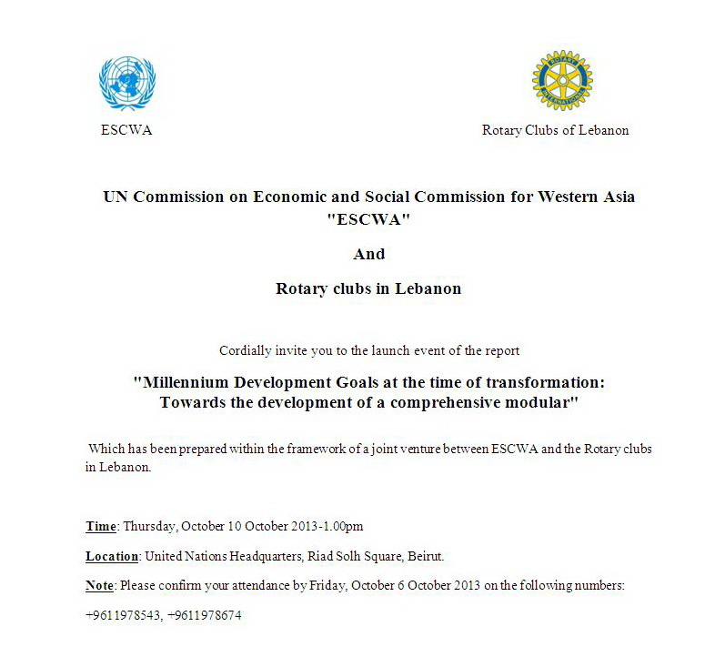
Fourth step:
The launching ceremony took place at UN House, ESCWA building, at 1pm on Thursday 10th of October 2013.

www.unmillenniumproject.org

